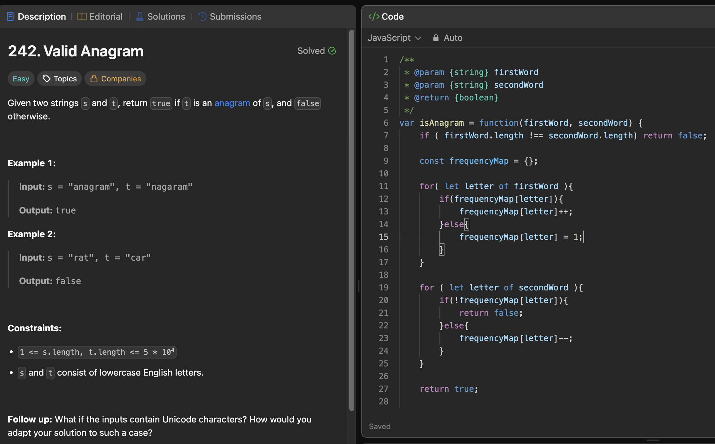

Anagram is something where the words must match.

Like subart = tarbus but subrat is not = to tarcar

1. So we first check if the length matches in the first place to compare further.
2. Then we create an empty object
3. With the first for loop we will build something like

if the first word was hello

* Then check if the letter exists in frequency map and if the letter exists we increment it by one. Else it is one.

1. In the second loop.

* We check if the letter doesnot exists.
* Otherwise we will subtract 1 from the cound
* Basically if all is 0 after substraction then we get a valid anagram.